**2015 QI Annual Evaluation**

1. **Transitions in Management: Inpatient Facility to Primary Care Practitioner**
2. **Data Collection – Readmissions**

Hospital readmissions are common, costly and negatively impact health outcomes. Data from the 2007 Healthcare Cost and Utilization Project (HCUP) on all-cause readmissions among non-elderly Medicaid patients revealed that Medicaid readmission rates were higher than commercially insured patients. For Medicare patients, nearly one in five were readmitted within 30 days of discharge from a hospital stay and estimates of the cost of these potentially preventable readmissions equates to $12 billion dollars annually.[1] Readmission rates can be indicators of continuity and coordination of care.

L.A. Care monitors admissions and readmissions use through several data sources. The Key Performance Indicator (KPI) Reports tracks Inpatient Readmission Rates per 1000 members per year (PTPY) for Medi-Cal and Medicare. LACC will be included in future reporting. And for Medi-Cal, a report of risk-adjusted hospital admissions rates was prepared comparing MCLA to the Plan Partners using 3M Clinical Risk Groups.

**2. Readmission Data Monitoring**

1. **KPI Reports – Inpatient 30-day Readmission Rates per 1000 members per year (PTMPY) for Medi-Cal (SPD and non-SPD), CMC, and LACC**

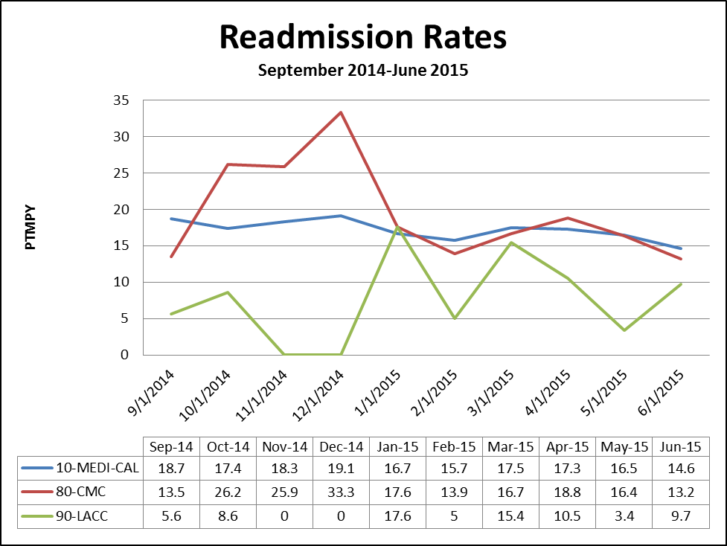

*Note 30-day inpatient readmission rates

1. **Risk-adjusted Hospital Admission rates for Medi-Cal (comparing MCLA to the Plan Partners) using 3M Clinical Risk Groups**

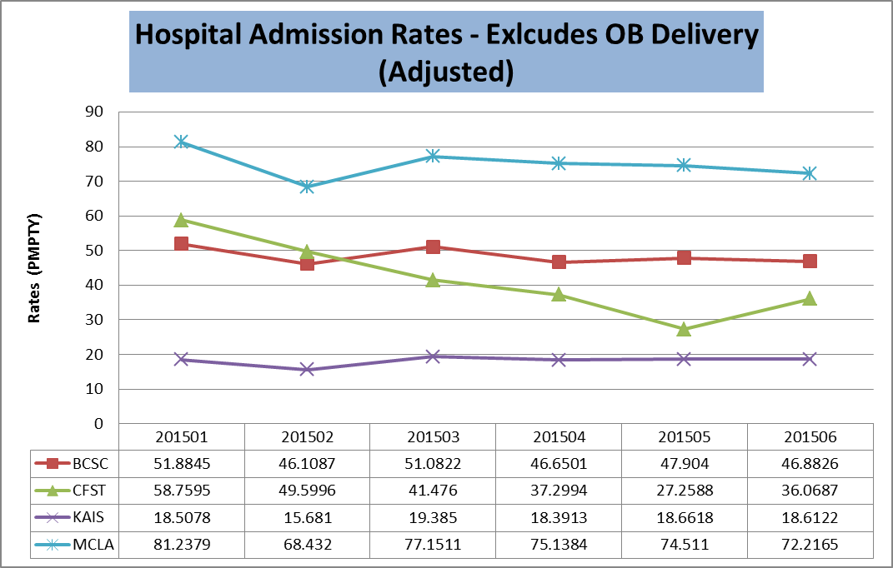

**3. Quantitative and Causal Analysis – Admissions and Readmissions**

For Medi-Cal from September 2014 to June 2015, the average Readmission Rate per thousand members per year (PTMPY) was 17.2%, with a slight downward trend (fewer readmissions) towards the end of the time frame depicted. Of note, the hospital admission rates are higher for MCLA compared to our Plan Partners but this may be linked to the finding that generally speaking, the severity of illness in MCLA population is about 14-18% higher than the average Medi-Cal population managed in L.A. Care based on 3M Clinical Risk Groups. With a greater number of admissions, there will likely be a subsequent increase in number of readmissions, thus monitoring both of these utilization measures is important for tracking/trending and care coordination purposes.

For Medicare-CMC from September 2014 to June 2015, the average Readmission Rate per thousand members per year (PTMPY) was 19.6%, with a downward trend (fewer readmissions) over the time frame depicted.

For LACC, there was more variability month to month in readmissions likely due to the smaller membership size. The average Readmission Rate per thousand members per year (PTMPY) was 7.6% over the time frame depicted.

Discharge from a hospital is a critical transition point in a patient’s care and organizations across the country are focused on hospital discharges as a high-yield opportunity to improve outcomes and reduce costs. However, knowledge of patients being admitted and discharged from hospitals is a barrier for L.A. Care’s network. PCPs do not know when patients have been discharged which has a significant impact on patients accessing time-sensitive follow-up services.

**Opportunities for Improvement**

There is opportunity to increase timeliness of data sharing to care managers and providers for inpatient admissions, specifically targeting hospitals with a high volume of inpatient admissions. Improving the timeliness of data sharing between the hospital, L.A. Care, and the IPAs/PCPs will have a positive impact on coordination and continuity of care for L.A. Care members.

**4. Intervention to act on Opportunity: HIT eConnect**

To increase timeliness of data sharing related to inpatient admissions, L.A. Care is taking action to enhance its network’s ability and infrastructure to communicate (share data) with L.A. Care’s Utilization and Care Management departments, IPAs and PCPs about which members are admitted inpatient. Timely exchange of this information can prompt the member’s PCP/staff to make follow-up calls and schedule appointments with members post-inpatient discharge leading to a potential reduction of readmissions.

Currently, L.A. Care receives hospital face sheets, clinical notes, and discharge summaries by fax. Given this lack of infrastructure to support efficient and timely communication of member admissions to the inpatient setting, L.A. Care has developed a pilot program called eConnect. In 2014, L.A. Care’s eConnect pilot program began working to enhance the networks infrastructure to electronically receive member inpatient admission data from hospitals by establishing an ADT (admission, discharge, transfer) feed from hospitals as well as establishing access by L.A. Care’s Care Management team to Hospital EHRs. ADT information is shared (via an online portal) with L.A. Care’s Utilization and Care Management department when members have been admitted to the inpatient setting; information that can then be shared with IPAs and subsequently PCPs. Thus, this pilot program directly impacts coordination and continuity of care for all lines of business (Medi-Cal, CMC, and LACC) since it offers care managers, IPAs and PCPs “real-time” knowledge of when their patients have been admitted to the inpatient setting. This improved communication network will also provide L.A. Care’s Utilization and Care Management departments with more timely access for concurrent review, discharge planning, and care coordination via read-only hospital EHR access. Looking forward, the eConnect Pilot Program will increase the number of participating hospitals with a goal to expand to more hospitals as well as initiate and track utilization of the information shared within the IPAs’ online portal.

**5. Measuring Intervention Effectiveness: HIT eConnect**

Through the eConnect Pilot Program’s interface, 10 hospitals are now able to electronically notify L.A. Care upon member admission, with an additional 8 hospitals having set systems in place and in the process of testing the eConnect ADT interface (expected “go-live” in February 2016).

1. 2015 eConnect Process Data on Inpatient Admission and Readmissions

| **Estimated Capture of Inpatient Admissions and Readmissions among**  **Active ADT eConnect Hospitals** | | | |
| --- | --- | --- | --- |
| **Hospital Group** | **Hospital Site** | **Estimated Admissions captured** | **Estimated Readmissions captured** |
| Alta | Alta – Los Angeles | 1,250 | 310 |
| Alta | Alta - Hollywood | 1,121 | 271 |
| Alta | Alta – Culver City | 587 | 154 |
| Alta | Alta - Norwalk | 593 | 136 |
| Citrus | Citrus – Queen of the Valley | 891 | 163 |
| Citrus | Citrus – Foothill Presbyterians Hospital | 195 | 35 |
| Citrus | Citrus – Inter Community | 591 | 108 |
| Memorial Care Systems | Long Beach Memorial | 1,488 | 354 |
| Memorial Care Systems | Miller Children’s Hospital | N/A | N/A |
| Valley Presbyterian Hospital | Valley Presbyterian Hospital | 1,005 | 192 |
| **Total Admissions/Readmissions for active ADT eConnect Hospitals (% of total Admissions or Readmissions/year)** |  | **7727 (18.7%)** | **1725 (21.8%)** |
| **End Goal: Total Admissions/Readmissions for ALL participating eConnect Hospitals (% of total ER visits/year)** |  | **End goal:**  **28,959 (69.9%)** | **End Goal:**  **5,757 (72.6%)** |
| Total L.A. Care Admissions/Readmissions visits/year for all Hospitals |  | 41,422 | 7,929 |

**6. Intervention Effectiveness: Discussion – Readmissions and eConnect**

As of 2015, among those 10 participating hospitals the ADT (admission, discharge, transfer) feed, L.A. Care is able to capture 18.7% of admissions and 21.8% of readmissions, up from 16.2% and 19.3%, respectively, in 2014. **Specifically for 2015, among participating hospitals 8,177 inpatient admissions were processed via eConnect**; noting that Valley Presbyterian Hospital went live in December 2015. By the end of the 3 year implementation process, L.A. Care will receive ADT data for approximately 69.9% of all admissions. L.A. Care has also established care manager access to 14 hospital EHRS as of the end of 2015 – usage of this access is tracked monthly. Over time, as the timeliness of ADT data exchange improves for the network, it is expected that readmission rates will improve as a reflection of more timely coordination and continuity of care.

1. 1 MedPAC. Report to Congress: Promoting Greater Efficiency in Medicare. June 2007. http://www.medpac.gov/documents/Jun2007.